Assignment 2

# Part I

## Question 1.1

**Describe including images for illustration the human biological neural network and how it works**

The human brain has a deep architecture. A given input is perceived at multiple levels of abstraction. Each level corresponds to a different area of the cortex. We process information in a hierarchical way with multi-level transformation and representation. You often hear people comparing the human brain to computers. A neural network simulates a lot of densely interconnected brain cells inside a computer so you can train it to learn things, recognize patterns, and make decisions in a human like way.

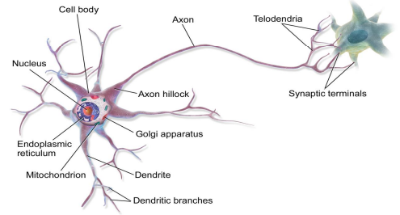

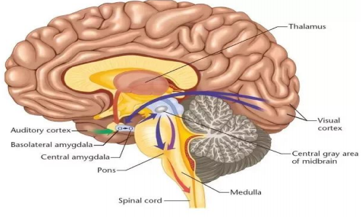

## Question 1.2

**Describe (including images for illustration) the McCulloch-Pitt neuron model, a.k.a. Threshold Logic Unit, that is considered as the simplest neural network and how it works**

The McCulloch Pitts neuron model is the simplest single layer neural network. A simple neural network has a single layer of input neurons feeding forward t one output layer. The most fundamental unit of deep neural networks is the perceptron. The McCulloch Pitts model mimics the functionality of a biological neuron. A neuron takes an input signal, processes it like the CPU, passes the output through a cable like structure to other connected neurons.

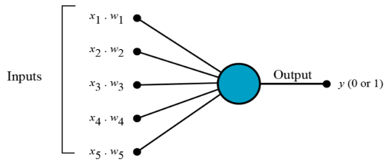

## Question 1.3

**Discuss (including images for illustration) how the pioneers in the AI field did imitate the human biological brain system to conceive the first artificial neural networks.**

The earliest neural network was developed in the 1940’s. In 1943 a seminal paper was published which proposed the first mathematical model of neural network. The unit of this model is a simple formalized neuron called a McCulloch Pitts neuron.

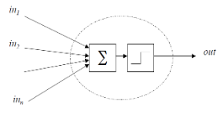

# Part II

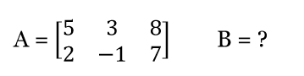

## Question .21

## **Matrix B with all its scalar elements**

B= $\left({2 3 \atop \begin{aligned}4 5 \\ 6 7\end{aligned}}\right)$

## Question 2.2

**The result of C = A x B**

A * B = $\left({5 3 8 \atop 2 -1 7}\right) * \left({2 3 \atop \begin{aligned}4 5 \\ 6 7\end{aligned}}\right)$

$$\left({\left(5x2\right)+\left(3x4\right)+\left(8x6\right) \left(5x3\right)+\left(3x5\right)+(8x7) \atop \left(2x2\right)+\left(-1x4\right)+\left(7x6\right) \left(2x3\right)+\left(-1x5\right)+(7x7)}\right)$$

$$\left({10+12+48 15+15+56 \atop 4-4+42 6-5+49}\right)$$

C = $\left({70 86 \atop 42 50}\right)$

## Question 2.3

**Specify the dimensions of C**

C is a 2 by 2 matrix

## Question 2.4

**Explain how to get the dot product C = A x B**

$$\left({\left(5x2\right)+\left(3x4\right)+\left(8x6\right) \left(5x3\right)+\left(3x5\right)+(8x7) \atop \left(2x2\right)+\left(-1x4\right)+\left(7x6\right) \left(2x3\right)+\left(-1x5\right)+(7x7)}\right)$$

$$\left({10+12+48 15+15+56 \atop 4-4+42 6-5+49}\right)$$

# Part III

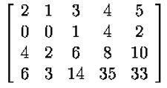

## Question 3.1

**Let’s consider this matrix as a vector of vectors. How many vector elements does this matrix have? Show each vector element, one by one.**

4 vectors

Index 0 = [2,1,3,4,5]

Index 1= [0,0,1,4,2]

Index 2 = [4,2,6,8,10]

Index 3 = [6,3,14,35,33]

[[2,1,3,4,5], [0,0,1,4,2], [4,2,6,8,10], [6,3,14,35,33]]

## Question 3.2

**Let’s consider this matrix as a vector of vectors. Add 3 to the vector element (of the matrix) of the index = 1. The addition is performed element-wise along Axis 1. Display the matrix with all its scalar elements after the operation has been done in the format of a 2Dmatrix.**

Index 0 = [2,1,3,4,5]

Index 1= [0,0,1,4,2,**3**]

Index 2 = [4,2,6,8,10]

Index 3 = [6,3,14,35,33]

[[2,1,3,4,5], [0,0,1,4,2,**3**], [4,2,6,8,10], [6,3,14,35,33]]

## Question 3.3

**Continuing from Question 3.2, i.e., after the above addition of 3 has been done: Flatten the matrix and display the result.**

[[2,1,3,4,5], [0,0,1,4,2,**3**], [4,2,6,8,10], [6,3,14,35,33]]

[2,1,3,4,5,0,0,1,4,2,3,4,2,6,8,10,6,3,14,35,33]

# Part IV

## Question 4.1

**Declare two constant tensors that have the values of 15 and 45. Add these two tensors and print out the results.**

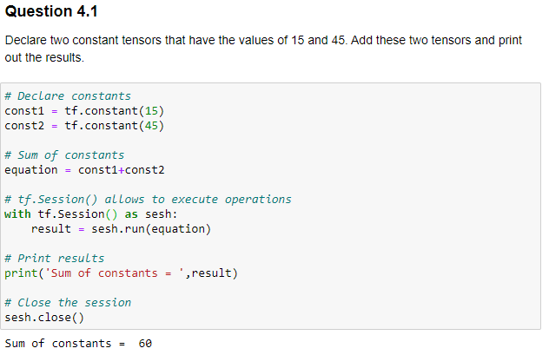

## Question 4.2

**Declare two variable tensors, a and b, that are initialized with scalar values of 2.75 and 8.5. Find their product and print out the result.**

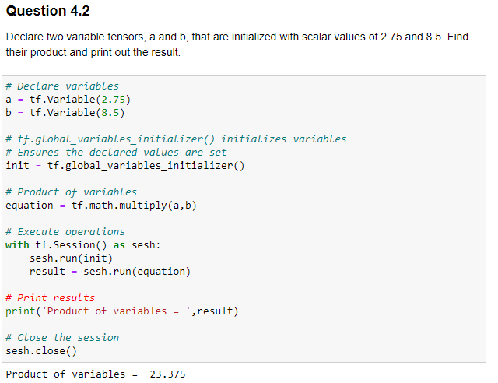

## Question 4.3

**Create two placeholders: x and y - that are both scalars of 32-bit floats. Assign 5.25 to x and 12.6 to y, multiply them together, and print out the results.**

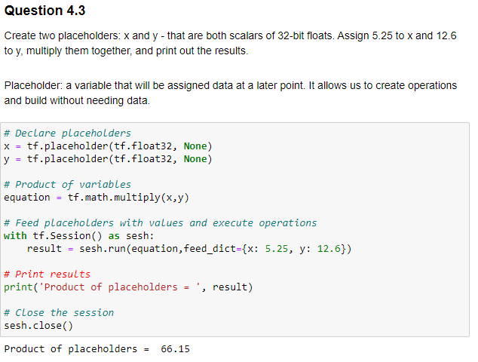

## Question 4.4

**Create one placeholder: z - that is an N-Dimensional array (N can be >= 1) that can have any shape (shape = None). Feed this vector [1, 3, 5, 7, 9] into z and multiply it by 3. Display the results.**

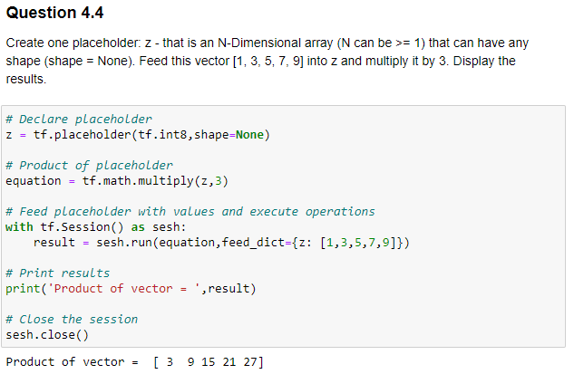

## Question 4.5

**Create a constant tensor that is a matrix of the shape (8, 8). The matrix is initialized with all ones (1). Create a variable tensor that is also a matrix of the shape (8, 8) and initialized with random integer values between 0 and 99. Add these two tensors and display the results.**

